UNIT TESTING

Here is an example for calculating the area of the circle

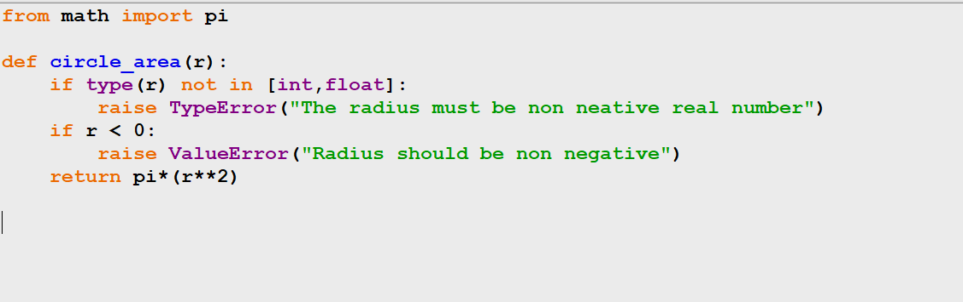

Unit test for the above code

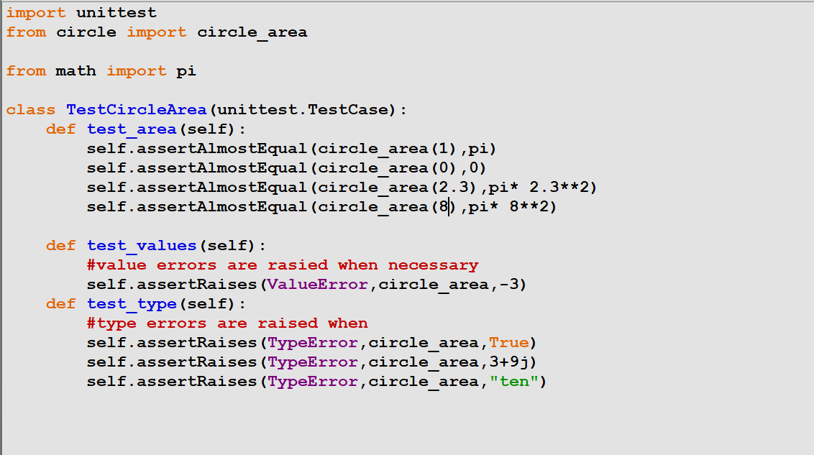

Written 3 types of test cases and all test passes

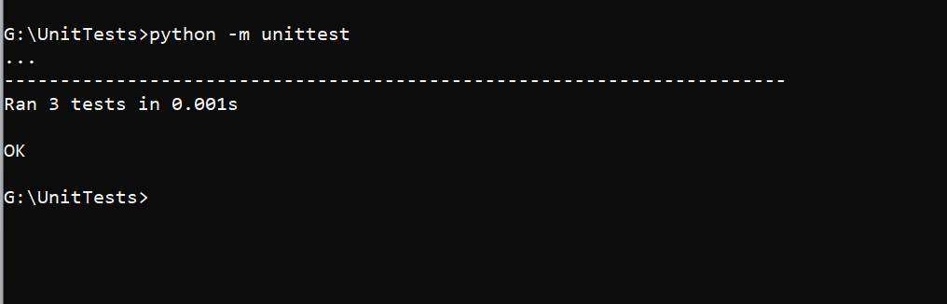

PYTEST

Lambda function

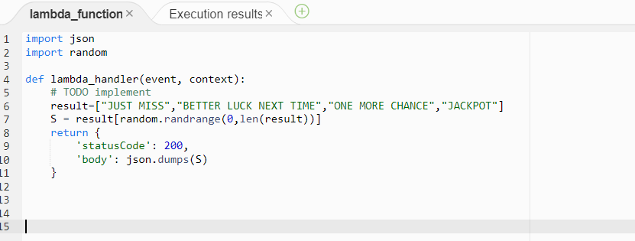

pytest for the API check

URL = "https://1ixgr1b4mh.execute-api.us-east-1.amazonaws.com/default/sample-api-function"

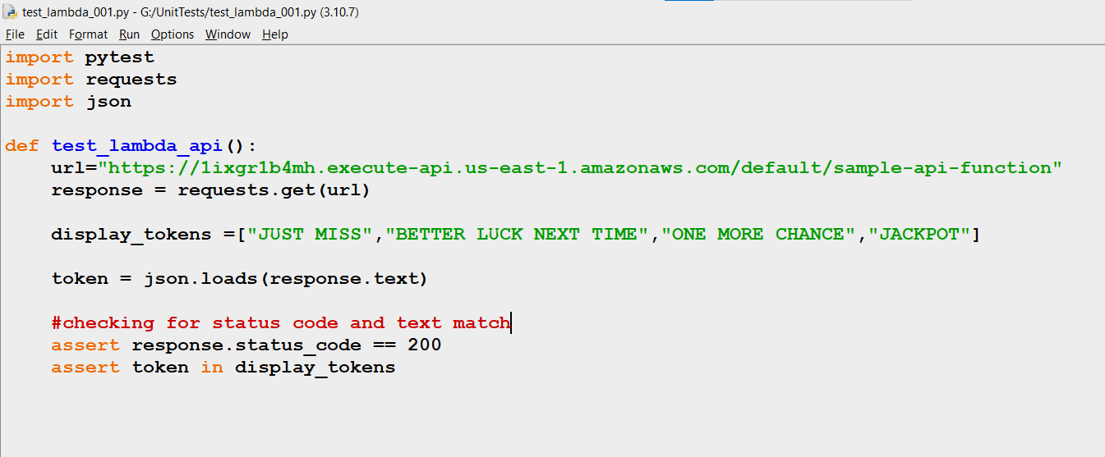

Pytest written for status_code check and text token check

